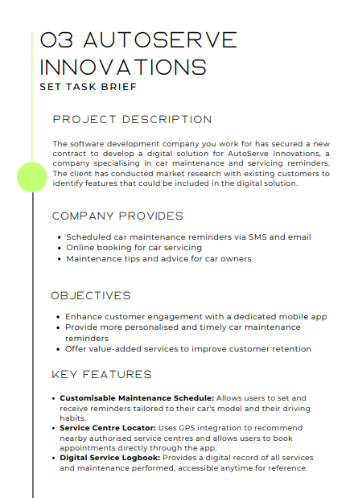

Proposal for AutoServe Innovations

1. Project Overview
AutoServe Innovations wants to upgrade how customers manage their car maintenance by rolling out a modern digital solution. The aim is to make reminders more personalised, give users an easier way to book servicing, and keep all their car maintenance info in one place. The improved system will boost convenience, customer engagement, and long-term loyalty.
The proposed solution will include:
- Customisable Maintenance Schedule
A tailored reminder system that adjusts to each user’s vehicle model, driving habits, and past service history.

- Service Centre Locator
GPS-powered tool recommending nearby service centres and allowing quick booking.

- Digital Service Logbook
A secure system storing all past service records, accessible from the app anytime.
These features align with AutoServe’s goal to improve the user experience and offer more value to every car owner using the service.

2. Problems Identified
Problem 1 - Generic Reminder System
Current reminders are basic and not tailored to different car models or user driving styles, making them less useful and easy to ignore.
Problem 2 - No Integrated Service Centre Locator
Users may struggle to find reliable garages nearby, slowing down the booking process and causing frustration.
Problem 3 - No Digital Logbook
Customers currently don’t have a unified place to track previous services, which can cause confusion and reduce trust in the system.

3. Proposed Solutions
Solution to Problem 1 - Smart Customisable Maintenance Reminders
A system that analyses user driving habits, car model, and historical data to generate personalised reminders via the app, SMS, or email.
Solution to Problem 2 - GPS-Driven Service Centre Locator
A built-in mapping system showing nearby approved service centres and allowing fast appointment booking through the app.
Solution to Problem 3 - Digital Service Logbook
A record-keeping platform storing all maintenance and servicing history, helping users stay organised and technicians stay informed.

4. Decomposition of Solutions
Customisable Maintenance Schedule
- Collect car details and user driving habits.
- Auto-generate personalised reminders.
- Send alerts via app notifications, SMS, and email.
- Allow users to edit preferences and reminder frequency.

Service Centre Locator
- Integrate GPS functionality to identify nearby garages.
- Display prices, ratings, and availability.
- Provide instant booking options.
- Confirm appointments with automated reminders.

Digital Service Logbook
- Store all servicing and maintenance events.
- Allow technicians to update records securely.
- Provide users with downloadable or shareable logs.
- Maintain history even across different devices.

5. Client and User Needs
AutoServe Innovations wants a system that makes car maintenance simple and stress-free.
Different users have different requirements:
- Older drivers: need large text, clear colour contrast, and straightforward navigation.
- Busy professionals: need fast booking, quick reminders, and mobile-friendly access.
- Car enthusiasts: appreciate detailed logs and advanced maintenance insights.
The digital solution must feel modern, reliable, and easy to use for all customers, fam.

6. Mitigating Potential Risks
Maintenance Reminders
- User Error: entering wrong car details → fix with validation checks.
- Technical Risk: reminders not being sent → monitoring + redundancy.
- Security Risk: unauthorised access to user schedules → strong RBAC and encryption.
Service Centre Locator
- User Error: choosing the wrong location → map previews + confirmation screens.
- Technical Risk: GPS misreads or outages → fallback to manual postcode search.
- Security Risk: leaking location data → encrypted data handling.
Digital Service Logbook
- User Error: technicians entering incorrect data → validation + confirmation prompts.
- Technical Risk: logs not saving or overwriting → backups + reliable backend.
- Security Risk: unauthorised edits → tracked edits & restricted access.

7. Security & Compliance Risks
- Data Privacy and Security
Protect user data with encryption, MFA, and regular audits.
- Unauthorised Access to Service Data
Use secure authentication and routine security checks.
- Weak Security Infrastructure
Enforce encryption, 2FA, and regular testing.
- Compliance Issues (GDPR)
Ensure user consent, data portability, and lawful processing.
- Accessibility Compliance
Add large text options, screen reader support, and high-contrast themes.

8. System Reliability Risks
- System Downtime
Cloud hosting, load balancing, and disaster recovery planning keep the platform reliable.
- Reminder Failures
Scalable infrastructure and constant system monitoring reduce failures.
- High Traffic Handling
Stress testing + scalable servers improve performance.
- Disaster Recovery
Regular backups and recovery drills prevent data loss.
- System Crash Under Load
Load balancing and cloud scaling minimise crashes.

9. User Experience Risks
- Poor User Adoption
Usability testing, onboarding guides, and support improve uptake.
- Forgotten Passwords
Secure reset processes and 2FA keep accounts protected.
- UI / Accessibility Limitations
Follow WCAG standards and gather user feedback.
- Poor Navigation
Continuous usability testing ensures easy access to reminders, bookings, and logs.

10. Content Accuracy Risks
- Incorrect Maintenance Guidance
Use expert reviews and frequent audits.
- Missing Car Model Information
Update the CMS regularly and allow user reporting.

11. Technical Risks
- Bugs and Glitches
Perform unit, integration, and user testing with a bug-tracking workflow.
- Performance Issues
Release regular updates and provide ongoing support.

